InBody Application in Oncology

i) Parameters of Utmost Importance for Onco-Surgeons
1. Extracellular Water to Total Body Water Ratio (ECW/TBW)
- Normal range: 0.36–0.39
- ECW/TBW > 0.40 → indicates edema or fluid overload
- Crucial for monitoring fluid shifts post-surgery, particularly after lymph node dissection in breast, gynecologic, or head & neck cancers.
- Helps differentiate between generalized edema vs. localized lymphedema.
2. Segmental ECW Ratio (Arm-to-Arm or Leg-to-Leg Comparison)
- Provides objective measurement instead of relying solely on limb circumference or physical exam.
- Early detection allows preventive interventions (compression therapy, physiotherapy).
- Elevated ECW/TBW ratio has been linked with higher complication rates and worse survival in cancer patients.
- Justifies routine monitoring to improve long-term outcomes.
3. Intracellular Water (ICW)
- Reduced ICW in the affected limb reflects impaired cellular nutrition and fluid balance.
- Important for post-surgery recovery since optimal ICW supports wound healing and tissue repair.
4. Skeletal Muscle Mass (SMM) & Strength Indicators
- Surgery and lymphedema often lead to reduced limb mobility → muscle wasting.
- Monitoring SMM helps surgeons assess whether reduced function is due to fluid overload or actual muscle atrophy.

5. Phase Angle (PhA)
- Reflects cell membrane integrity & immune function.
- Low PhA may indicate poor nutritional status or impaired healing capacity post-surgery.
- Important for predicting recovery time and complication risk.

Lymphedema – Case – 1
54 years, female, 57kg,162 cmng axillary lymph node removal after surgery
The arm & hand gradually swelled, with pain
Patient with Lymphedema after surgery
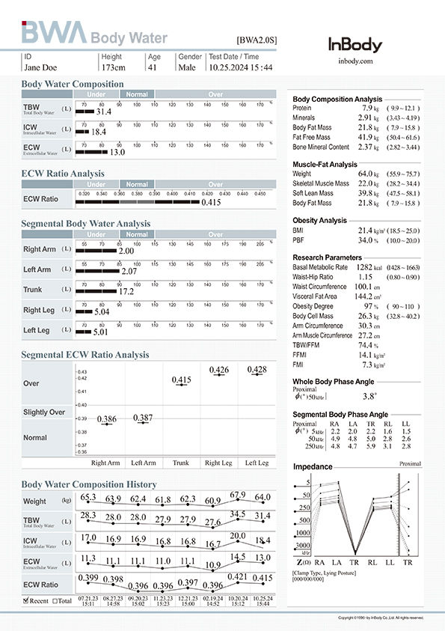
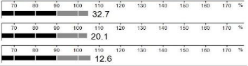
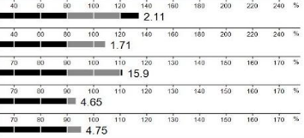
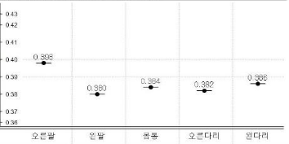
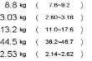
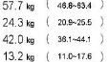
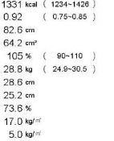

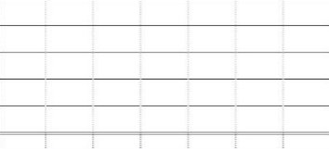
Lymphedema occurred in the right arm
following axillary lymph node removal after surgery
The arm & hand gradually swelled, with pain
Undergoing rehabilitation therapy while
monitoring improvement through Segmental ECW ratio analysis
justification of BIA Use
✓ Segmental ECW ratio detects side-to-side differences → confirms localized lymphedema
✓ Provides objective monitoring of therapy effectiveness during rehab
✓ Helps distinguish swelling from muscle atrophy by checking SMI & PhA alongside ECW

Lymphedema Case – 2
Malignant Lymphoma Pateint-
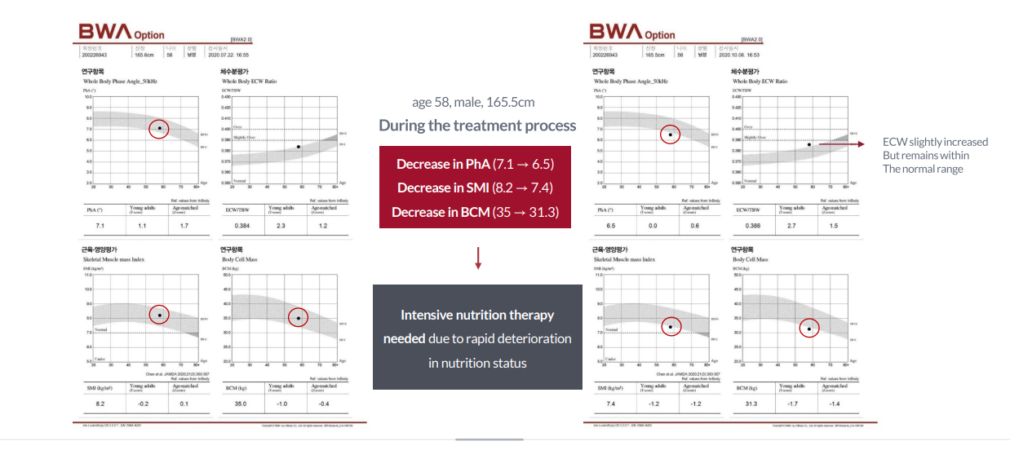

ECW/TBW ratio identifies systemic vs. localized edema (important in hematological cancers)
✓ PhA decline signals cellular damage or poor nutritional status, guiding supportive care
✓ Enables longitudinal tracking through chemotherapy/rehab phases → ensures early interventions.

Lymphedema: Pre- and Post-Surgery Research

1. Breast Cancer–Related Lymphedema Pre- and Post-LVA Surgery
Study: BIA in patients with breast cancer–related lymphedema before and after lymphaticovenular anastomosis (LVA) (2022)
- Segmental multifrequency BIA was performed on 25 patients before and 6 months after LVA.
- Strong correlations found between segmental BIA and limb volume measurements:
  - Interlimb extracellular water ratio: r = 0.612 (p < .01)
  - Volume vs. impedance correlation: r = 0.784 (p < .001)
  - Phase Angle inversely correlated: r = −0.556 (p < .01)
(PubMed)
- Application: BIA reliably tracks severity changes and recovery after surgical lymphedema intervention.

2. Predicting Post-Surgical Edema via Whole-Body BIA
Study: Whole-body single-frequency BIA in breast cancer patients—before surgery, then at 2 days, 1, 3, 6, and 12 months after.
- Resistance (R) in BIA had:
  - Sensitivity: ~85.7%
  - Specificity: ~97.4% for predicting upper-limb edema
  - Negative predictive value: 97.4% (excellent at ruling out edema)
(PubMed)
- Additional study: Resistance (R) and Phase Angle (Pa) showed ~75% sensitivity, and specificity of ~86% (R) and 83% (Pa); both NPV ~96%—again, great for ruling out early edema.
(PubMed)
- Application: Whole-body BIA parameters like R and Pa are strong early screening tools for edema risk post-mastectomy. They flag people unlikely to develop swelling—valuable for triaging follow-ups.

3.Early Detection of BCRL with InBody 720
Study: Reference values for detecting breast cancer–related lymphedema using InBody 720 (2021)
- 70 patients with unilateral BCRL, 643 healthy controls
- Significant differences in:
  - ECW/TCW ratio
  - Segmental ECW ratios between affected and healthy arms
- Diagnostic cutoff thresholds established using:
  - Youden index
  - Mean + 2SD
  - Mean + 3SD
Reference: PMC8241780
- Application: InBody 720 provides objective cutoff values for early detection and diagnosis of breast cancer–related lymphedema.

4. Reliable Segmental Monitoring with InBody S10
Study: Feasibility of segmental multi-frequency BIA using InBody S10 for mild–moderate BCRL (2020)
- High test–retest reliability (ICC > 0.9)
- Segmental ECW/TBW ratios strongly correlated with limb volume (r > 0.6, p < 0.01)
- Detected >10% inter-limb differences in early lymphedema cases
- Provided reproducible values across repeated tests
Reference: PMC7850733
- Application: InBody S10 allows accurate, reproducible monitoring of segmental fluid changes pre- and post-surgery in lymphedema patients.

InBody application – Summary
1. Early, Non-Invasive Detection
- Traditional methods (tape measurement, water displacement) detect swelling only after visible progression.
- BIA identifies subclinical lymphedema by detecting segmental ECW/TBW changes before swelling becomes clinically apparent.
2. Objective & Quantitative Assessment
- Provides numerical data (ECW ratios, ICW/ECW distribution) for each limb.
- More precise than subjective grading scales.
- Useful for documenting progression and comparing pre- vs. post-surgery status.
3. Monitoring Postoperative Complications
- Detects fluid overload, ascites, or localized edema after cancer surgery.
- Helps distinguish lymphedema from systemic causes of swelling (cardiac, renal, hepatic).
4. Guiding Rehabilitation & Treatment
- Allows oncologists and physiotherapists to track improvements with compression therapy, physiotherapy, or medical interventions.
- Ensures targeted interventions for affected limbs.

